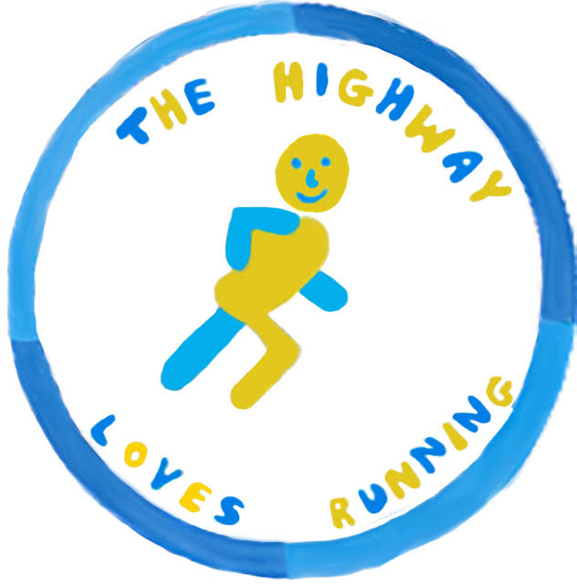

THE HIGHWAY

The Highway 10K sponsored by COOLINGS

SUNDAY 22nd SEPTEMBER 2019 – 10AM

- Start and Finish at The Highway Primary School, Orpington, Kent, BR6 9DJ
- 10K race 10:00 Start
  - Affiliated runner: £14 before 31st July, £16 after 1st August, £20 on the day
  - Unaffiliated runner: £16 before 31st July, £18 after 1st August, £20 on the day
- Refreshments, food and family fun on the day (including a 2K family fun run)
HOW TO ENTER
Please fill in the form below and return to The Highway, Orpington, BR6 9DJ or bring with you on the day.
All proceeds go to the Friends of The Highway registered charity (#802304), raising money for The Highway Primary School.
For more information visit us on www.thehighway10k.com or email info@thehighway10k.com
---------------------------------------------------------------------------
THE HIGHWAY 10K ENTRY FORM- sponsored by Coolings
Please enter me for the TH10K. I confirm that I am medically fit and enter the TH10K at my own risk.
I fully understand that the organisers can in no way be held responsible for any injury, illness or loss to my person or belongings during or as a result of the event.
Title: MR MISS MRS MS OTHER _______________________
First Name: ______________________________ Surname: ________________________________________
Address: _________________________________________________________________________________
_____________________________________ Post Code: _____________ Telephone: ___________________

Email: __________________________________ Male Female Date of Birth*: ________________
Affiliated: Yes No Club ________________________________ UKA Number _________________
I am happy for any photographs taken on the day to be used by the local media, TH10K website and TH10K social media
Yes No
I am happy for the Friends of The Highway to contact me about future TH10K events: Yes No
Signature: ____________________________________
Date: ___________ _____________________________________________________________________________
*Please note if you are aged 16 or 17, a parental consent form must be submitted alongside this entry form.
Friends of the Highway will only contact you according to the permissions selected above and to communicate event arrangements and results. Your personal data declared above will be stored for the purpose of The Highway 10K execution only. Your data will not be shared with any other parties. All personal data is stored in a secure database. If you wish to view or have your personal data removed from our database, please contact info@thehighway10k.com

