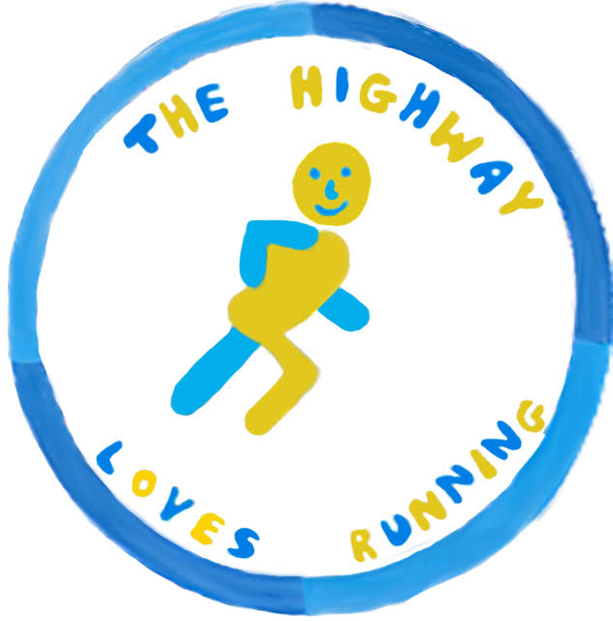

THE COOLINGS

HIGHWAY 10K

SUNDAY 22nd SEPTEMBER 2019– 10.00AM
If your child, aged 16 or 17 wishes to enter The Highway 10K event, please complete and submit the parental permission slip below alongside the TH10K entry form.
Please return completed forms to The Highway Primary School, Orpington, BR6 9DJ or drop it off at registration on race day.
For more information visit us on www.thehighway10k.com or email info@thehighway10k.com
---------------------------------------------------------------------------
The Highway 10K Parental Permission Slip for U18’s

I, _______________________________________ (insert parent/guardian full name) confirm that I authorise

my child__________________________ (insert U18’s full name) to run in the Highway 10K on Sunday 22nd September 2019.
I confirm that they are medically fit and enter at your own risk.

I fully understand that the organisers can in no way be held responsible for any injury, illness or loss to
any runner or their belongings during or as a result of the event.

Parent/guardian details:
Title: MR MISS MRS MS OTHER _______________________
First Name: ______________________________ Surname: ________________________________________
Address: _________________________________________________________________________________
_____________________________________ Post Code: _____________ Telephone: ___________________

Email: _________________________________________________

Relationship to child: __________________________________
I am happy for any photographs taken on the day of my child to be used by the local media, TH10K website and TH10K social media
Yes No

Signature: __________________________________________ Date: _________________________

